

**DEPARTMENT OF ELECTRICAL AND ELECTRONICS**

**ENGINEERING**

# NATIONAL INSTITUTE OF TECHNOLOGY DELHI

A Major Project Work Report

On

### CHARGING OF ELECTRIC VEHICLE WITH SOLAR ENERGY USING MPPT CONTROLLER

Submitted in partial fulfilment of the requirements of the degree of

Bachelor of Technology (2018-2022)

In

Electrical and Electronics Engineering

by

### Adarsh Attri (181230006)

**Amit Kumar (181230008)**

### Mayank Sharma (181230028)

Supervised by: **Dr. Manoj Kumawat** Assistant Professor

Department of Electrical & Electronics Engineering

**APPROVAL SHEET**

This project work entitled **Charging of Electric Vehicle with Solar Energy using MPPT**

**controller**

**Attri, Amit Kumar** and **Mayank Sharma**

By **Adarsh**

is approved for the degree of Bachelor of Technology.

**Examiners**

**Supervisor**

**Dr. Manoj Kumawat**

**Date: Place:**

## DECLARATION

In all our modesty, we wish to record here that this Project Report work is an authentic record of our own work as requirements of Project work for the award of degree of B. Tech (EEE), National Institute of

Technology, Delhi

and a sincere attempt have been made for the presentation of this project report. We also declare that honesty and integrity have been maintained while preparing this project and violation of any rules will cause for disciplinary action by the Institute. We also trust that this study will not only prove to be an academic interest but also will be able to provide an insight into the area of technical knowledge.

**Signature of Students**

**Signature of Project Supervisor**

Adarsh Attri (181230006)

Amit Kumar (181230008)

Mayank Sharma (181230028)

Date: 15/05/2022

### CERTIFICATE

This is to certify that the work entitled, **Charging of Electric Vehicle with Solar Energy using MPPT controller** submitted by **Adarsh Attri** (181230006), **Amit Kumar** (181230008) and **Mayank Sharma** (181230028) in partial fulfilment of the requirements for the award of Bachelor of Technology in **Electrical and Electronics Engineering** at the National Institute of Technology Delhi is an authentic work carried out by them under my supervision and guidance. To the best of my knowledge, the matter embodied in the project work has not been submitted to any other University

/ Institute for the award of any Degree or Diploma.

Supervisor

**Dr. Manoj Kumawat**

Assistant Professor, NIT DELHI

Department of Electrical & Electronics Engineering

## ACKNOWLEDGEMENTS

We are very thankful to our project work guide **Dr. Manoj Kumawat**, Assistant Professor, Department of Electrical and Electronics Engineering, National Institute of Technology, Delhi, to introduce us to this topic and for their inspiring guidance, constructive criticism and valuable suggestions throughout this project work.

We would also like to thank all the supporting staff of the Department of Electrical and Electronics Engineering and all other departments who had been helpful directly or indirectly in making our project a success.

Last but not the least, we would like to thank all our friends who came across us and indirectly taught us for this project and for supporting and motivating us to pursuing our interest throughout this project work.

### Adarsh Attri (181230006)

**Amit Kumar (181230008)**

**Mayank Sharma (181230028)**

## ABSTRACT

Electric vehicle revolution is speeding up but the charging of battery and battery life of a cell pack of electric vehicle is still a concern. Batteries made of multiple cells connected in series are often used as a power source for common electronic

devices. had already worked on the various cell balancing techniques to

We

enhance the performance and durability of the battery in an electric vehicle and provided a better approach to balance the cells in lesser time and enhanced efficiency.

Also, were

we were researching on various charging systems of that battery which mostly conventional methods of charging the electric vehicle involving

more losses and lesser efficiency.

In this project, designed a more efficient way of charging using renewable

we

source of energy i.e., sun with a blend of Maximum Power Point Tracking (MPPT) controller which is used to track the point where the solar panel can produce maximum output power. In recent years, a lot of emphasis has been laid towards solar energy utilization but still there is huge scope in its improvement, especially in increasing its efficiency. Since the nature of this energy is highly volatile, so it becomes so important to develop its main components which are power converter and MPPT controller.

.

## CONTENTS

|  |  |
| --- | --- |
| **APPROVAL SHEET** | **i** |
| **DECLARATION** | **ii** |
| **CERTIFICATE** | **iii** |
| **ACKNOWLEDGEMENTS** | **iv** |
| **ABSTRACT** | **v** |
| **CONTENTS** | **vi** |
| **LIST OF FIGURES** | **viii** |
| **LIST OF TABLES** | **viii** |
| **Chapter 1: Introduction** | **1** |
| 1.1: Introduction | 1 |
| 1.2: Motivation | 2 |
| 1.3: Objectives | 3 |
| 1.4: Methodology | 3 |
| **Chapter 2: Theory & Background** | **4** |
| 2.1: MOSFETs | 4 |
| 2.2: Working principle of MOSFTs | 4 |
| 2.3: Inductors | 5 |
| 2.4: Diode | 6 |
| 2.5: Solar Energy Potential | 7 |
| 2.6: Solar PV Panel | 7 |
| 2.7: Battery | 8 |
| 2.8: Mathematical Model of Solar PV | 9 |
| 2.9: Power Point Tracker | 10 |
| 2.10: Transformer | 10 |
| **Chapter 3: Maximum Power Point Tracking** | **12** |
| 3.1: Need of Power Point Tracking | 12 |
| 3.2: Various Techniques of MPPT | 12 |
| 3.3: Perturbation & Observation | 13 |
| 3.4: Particle Swarm Optimization | 15 |

**17**

**Chapter 4: Literature Review**

#### Chapter 5: Conventional Charging Methodology 19

* 1. : Conventional Charging Methodology 19
  2. : AC/DC Rectifier 19
  3. : DC/AC Inverter 20
  4. : DC/DC Buck-Boost Converter 21

#### Chapter 6: Proposed Charging Methodology 23

* 1. : Proposed Charging Methodology 23
  2. : Flow chart for MPPT Algorithm 25

#### Chapter 7: Simulation & Results 27

* 1. : Charging of EV with solar Energy using MPPT Controller 27
  2. : Comparison between both the charging methodologies 30

#### Conclusion & Future Scope 31

#### References 32

## LIST OF FIGURES

Fig 2.1: MOSFET block Diagram 5

Fig 2.2: Inductor 6

Fig 2.3: Diode 6

Fig 2.4: Solar Panel 8

Fig 2.5: Battery 8

Fig 2.6: Single Diode Model of Solar PV cell 9

Fig 3.1: Flow Chart for P&O Based MPPT 14

Fig 3.2: Flow Chart for PSO Based MPPT 15

Fig 5.1: Block Diagram of Conventional Diagram 19

Fig 5.2: Circuit for full wave Rectifier 20

Fig 5.3: Circuit for full bridge Inverter 21

Fig 5.4: Circuit for Buck-Boost Converter 22

Fig 6.1: Block Diagram of Proposed Model 23

Fig 6.2: PV-Curve 24

Fig 6.3: Algorithms used for MPPT 25

Fig 7.1: Simulink Model for Charging of EV with Solar energy 28

Fig 7.2: Simulation Results 28

Fig 7.3: IV and PV Curve for the Array 29

**LIST OF TABLES**

Table 7.1: Parameter for Simulink Model 27

Table 7.2: Comparison between both the charging methodologies 30

## CHAPTER 1 INTRODUCTION

#### Introduction

know that vehicles depend on fossil fuels for power and also know

we

We all

that fossil fuel is slowly decreasing and there will come a time when fossil fuels will vanish from our world. That's why scientist found its alternative in the form of electric vehicles. Due to these reasons, electric vehicles are slowly replacing the normal vehicles. However, there are several problems hampering development of electric vehicles, such as the short life span of batteries, poor performance of start-up, and a short driving range.

There is another concern for normal vehicles that its spreads a lot pollution and in future due to the less quantity of fossil fuel, its usage will be negligible. In order to resolve these negative problems caused by normal vehicles, researching and applying new alternative energy in the field of automobile are attracting people’s attention and also people attention are shifting towards electric vehicles because electric vehicles produce very less pollution and electricity is produce by renewable source. Due to these reasons Electric vehicles, fuel cell vehicles, and solar vehicles are emerging on a large scale.

Currently, developing new types of energy systems is very important because of the increasing human population and if population is more, we need greater energy-based devices for survival. Due to the continuous increase in the human population fossil fuel is decreasing and increasing greenhouse gas emissions is another environmental concern. Furthermore, due to the better technology in modern era, more electronic devices are being used to replace manpower thus leading to a further increase in energy consumption.

Photovoltaic (PV) power will never end like non-renewable source like fossil fuels. However, although it is renewable source and environmentally friendly,

some disadvantages exist like such as low transfer efficiency and low power density. Its second problem is that due to being expensive, we cannot apply it on a large-scale application of solar energy. Examine on how to enhance the transfer efficiency of PV power systems is now becoming popular among scientists and researchers. We proposed a charging system for electric vehicles by solar energy with the help of MPPT. This system can not only explore the charging behaviour with maximum power point tracking (MPPT) but also decrease the charging time and increase the battery life. This transfer energy system achieves a high efficiency of 90.0%.

Energy coming through suns radiations when in contact with the earth atmosphere and or surface as irradiances is known by solar energy. Presently, solar energy is the most commercially feasible option because Solar energy is consistent during the year and sunlight is predictable for any number of years at any location. Solar becomes very economical. That's the main reason rooftop solar installations especially for houses and many solar installations in other area have grown rapidly. Solar needs a shadow-free area for panel installation and it is very easy to install and also based on forecasts and projections solar power should be the cheapest power in coming decades.

#### Motivation

In this project, have studied conventional methodology for charging an

we

electric vehicle. There were some limitations of that methodology which motivated us to design a more efficient and reliable charging method for electric vehicle. Many of the limitations had been overcome by our proposed system which includes:

1. Efficiency had been increased
2. System is less complex
3. Charging method is based on renewable source of energy
4. Less number of switches used hence economical

#### Objectives

Our first objective is:

1. To introduce a renewable charging method to an electric vehicle using solar energy with the help of MPPT controller to maximize the power output.

second objective is:

Our

1. Comparison of losses in conventional method of charging and proposed method of renewable charging using solar panels.

#### Methodology

For the methodology process, first different type of charging method conventional charging method and

we

need to do some literature review on and MPPT techniques. The problem in low efficiency and how to overcome the

problem will be justified with using new charging method with MPPT algorithm.

Conventional type of charging has limited source and due to a greater number of switches from input to output, switching losses present in this are more, due to which output power in battery is lowered as compare to that in renewable charging method with same input rating. To overcome this, an alternate methodology is used that is based on solar energy transfer using MPPT controller.

## CHAPTER 2 THEORY & BACKGROUND

#### MOSFETs

MOSFET stands for **Metal Oxide Field Effect Transistor**, MOSFET was invented to overcome the disadvantages present in FETs like high drain resistance, moderate input impedance, and slower operation. So, a MOSFET can be called the advanced form of FET. In some cases, MOSFETs are also be called **IGFET** (Insulated Gate Field Effect Transistor). Practically speaking, MOSFET is a voltage-controlled device, meaning by applying a rated voltage to the gate pin, the MOSFET will start conducting through the Drain and Source pin. In general, the MOSFET is a four-terminal device with a **Drain (D), Source (S), gate (G)** and a Body (B) / Substrate terminal. The body terminal will always be connected to the source terminal hence, the MOSFET will operate as a three- terminal device.

#### Working Principle of MOSFET

The main principle of the MOSFET device is to be able to control the voltage and current flow between the source and drain terminals. It works almost like a switch and the functionality of the device is based on the MOS capacitor. The MOS capacitor is the main part of MOSFET.

The semiconductor surface at the below oxide layer which is located between the source and drain terminal can be inverted from p-type to n-type by the application of either a positive or negative gate voltage respectively. When we apply a repulsive force for the positive gate voltage, then the holes present beneath the oxide layer are pushed downward with the substrate.

The depletion region populated by the bound negative charges which are

associated with the acceptor atoms. When electrons are reached, a channel is developed. The positive voltage also attracts electrons from the n+ source and drain regions into the channel. Now, if a voltage is applied between the drain and source, the current flows freely between the source and drain and the gate voltage controls the electrons in the channel.

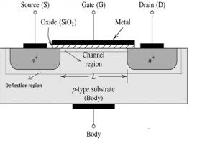

#### Fig.2.1: MOSFET Block

* 1. **Inductors**

An inductor, also called a coil, choke, or reactor, is a [passive](https://en.wikipedia.org/wiki/Incremental_passivity) two- terminal [electrical component](https://en.wikipedia.org/wiki/Electronic_component) that stores energy in a [magnetic field](https://en.wikipedia.org/wiki/Magnetic_field) when [electric](https://en.wikipedia.org/wiki/Electric_current) [current](https://en.wikipedia.org/wiki/Electric_current) flows through it. An inductor typically consists of an insulated wire wound into a [coil](https://en.wikipedia.org/wiki/Electromagnetic_coil).

When the current flowing through the coil changes, the time-varying magnetic field induces an [electromotive force](https://en.wikipedia.org/wiki/Electromotive_force) (*e.m.f.*) ([voltage](https://en.wikipedia.org/wiki/Voltage)) in the conductor, described by [Faraday's law of induction](https://en.wikipedia.org/wiki/Faraday%27s_law_of_induction). According to [Lenz's law](https://en.wikipedia.org/wiki/Lenz%27s_law), the induced voltage has a polarity (direction) which opposes the change in current that created it. As a result, inductors oppose any changes in current through them.

An inductor is characterized by its [inductance](https://en.wikipedia.org/wiki/Inductance), which is the ratio of the voltage to the rate of change of current. Below shown is the electrical symbol for the inductor.



#### Fig.2.2: Inductor

* 1. **Diode**

A diode is a two-[terminal](https://en.wikipedia.org/wiki/Terminal_(electronics)) [electronic component](https://en.wikipedia.org/wiki/Electronic_component) that conducts [current](https://en.wikipedia.org/wiki/Electric_current) primarily in one direction (asymmetric [conductance](https://en.wikipedia.org/wiki/Electrical_conductance)); it has low (ideally zero) [resistance](https://en.wikipedia.org/wiki/Electrical_resistance_and_conductance) in one direction, and high (ideally infinite) [resistance](https://en.wikipedia.org/wiki/Electrical_resistance_and_conductance) in the other.

A semiconductor diode, the most commonly used type today is a [crystalline](https://en.wikipedia.org/wiki/Crystallinity) piece of [semiconductor](https://en.wikipedia.org/wiki/Semiconductor) material with a [p–n junction](https://en.wikipedia.org/wiki/P%E2%80%93n_junction) connected to two electrical terminals.

A diode has two ‘sides and each side are doped differently. One side is the “p- side”, this has a positive charge. The other side is the “n-side”, this has a negative charge. Both of these sides are layered together to form what is known as the “n- p junction” where they meet.

The most common function of a diode is to allow an electric current to pass in one direction (called the diode's forward direction), while blocking it in the opposite direction (the reverse direction). As such, the diode can be viewed as an electronic version of a [check valve](https://en.wikipedia.org/wiki/Check_valve). This unidirectional behaviour is called [rectification](https://en.wikipedia.org/wiki/Rectification_(electricity)), and is used to convert [alternating current](https://en.wikipedia.org/wiki/Alternating_current) (ac) to [direct](https://en.wikipedia.org/wiki/Direct_current) [current](https://en.wikipedia.org/wiki/Direct_current) (dc). Below shown is the electrical symbol for the Diode.

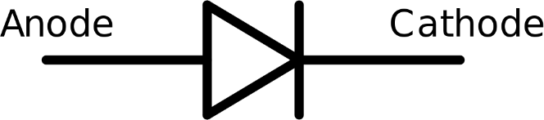

#### Fig.2.3: Diode

* 1. **Solar Energy Potential**

Solar energy could be a best option for the future world because of several reasons:

* First, solar energy is the most abundant energy source of energy and sun emits it at the rate of 3.8*1023 kW, out of which approx. 1.8*1014 kW is intercepted by the earth.
* The solar Energy would definitely be a best option for future energy demand since it is superior in terms of availability, cost effectiveness, accessibility, capacity and efficiency compared to other renewable energy sources.
* Utilization and tracking of solar energy do not have any harmful impact on ecosystem in which natural balance is kept consistent for the betterment of living organisms but when it comes to utilization of solar energy there a couple of ways present and we know by them by the names of solar photovoltaic and solar thermal or concentrated technique. Nowadays the thermal techniques are redundant because of their very less efficiency when compared to the photovoltaic one. When it comes to practical implementation of solar photovoltaic there are certain challenges that need to be tackled like light irradiance, partial shading, and accumulation of dust. So, to deliver the maximum power and high efficiency here we proposed a new charging methodology.

#### Solar PV Panel

Solar PV Panel is basically an interconnected grid or an array of photovoltaic (PV) solar cells which are generally made up of silicon because silicon easily emits electrons with the help of sun’s energy and these electrons is responsible for the flow of current in the circuit. But the amount of current totally depends upon the intensity of irradiance by the sun. More the irradiance, more the output

power. We can also say that solar panel is a device that directly converts Sunlight into the electrical energy. The effect that is responsible for this conversion is known as photovoltaic effect. Below is the example image of how a solar panel looks like.

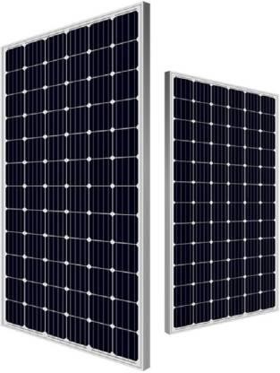

#### Fig.2.4: Solar Panel

* 1. **Battery**

Battery is a device that stores electrical energy in the form of chemical energy and then again converts chemical energy to electrical energy when taken for further use such as to run any electrical appliance. This is used in solar system to store excess amount of energy drawn from solar panel so that it can be further used when there is absence of sunlight.

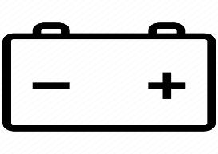

#### Fig.2.5: Battery

* 1. **Mathematical Model of Solar PV**

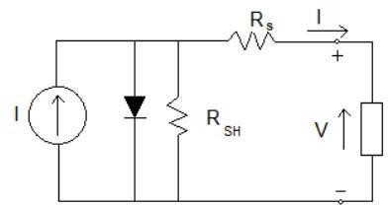

#### Fig 2.6: Single Diode Model of Solar PV Cell

In this model we consider a current source (I) along with a diode and series resistance (RS). The shunt resistance (RSH) in shunt is very high, has negligible effect and can be neglected.

The o/p current from the PV array is

**I = Isc – Id (1)**

#### Id = Io(eqV/kT – 1) (2)

Here, **Io** = Reverse saturation current of the diode

**q** = electron charge

**V** = voltage across the diode

**k** = Boltzmann constant (1.38*10-19 J/K)

**T** = Junction temperature in Kelvin (K). From eq. (1) and (2)

#### I = Isc – Io(eqV/kT – 1) (3)

By using approximations,

#### I = Isc – Io (eq((V+IRs)/nkT) - 1) …(4)

Where, ‘I’ is the photovoltaic cell current, V is the PV cell voltage, T is the temperature (Kelvin) and n is the diode ideality factor.

#### Power Point Tracker

The aim of MPPT is to extract and maintain the maximum power from the PV panels at any environmental condition, that by matching its I-V operating point with the load characteristics. Detailed study has been presented about MPPT in next chapter.

## CHAPTER 3

**MAXIMUM POWER POINT TRACKING**

#### Need of Power Point Tracking

Among the renewable energy sources, the energy through the solar photovoltaic effect can be considered the most necessary and prerequisite sustainable resource because of the ubiquity, large quantity, and sustainability of solar energy. Irradiance and temperature are the main factors on which performance of a solar panel depends. Since, PV module has non-linear characteristics, it is necessary to model it and simulate for MPPT of PV system application. A PV module generates small amount of power, so the task of a MPPT in a PV energy conversion system is to continuously tune the system so that it will be able to draw maximum power from the solar array regardless of weather or load conditions.

**MPPT:** There are two main categories of MPPT techniques: Indirect & Direct techniques. Indirect techniques include the constant voltage, open circuit voltage and short circuit current methods. In this type of tracking, manageable assumption and periodic estimation of the MPPT are made with easy measurements. For example, only operating voltage at different seasons is adjusted in fixed voltage technique. In winter higher MPP voltage and in summer lower MPP voltage is assumed at the same irradiation which is not possible because temperature and irradiation vary during a day within the same season. That’s why it is not a very accurate method for MPPT.

Among indirect MPPT techniques, open circuit voltage (OV) method is most common method. In this method it is assumed that MPP voltage is proportional to open circuit voltage.

***VMPP = k * VOC***

Here, ‘k’ is a constant and its value for crystalline silicon is usually 0.7- 0.8. This is the simplest method to implement. But, ‘k’ is just an approximation constant which leads to reduced efficiency, and every time the system needs to find the new open circuit voltage when the illumination condition modifies. Every time to find new OC voltage connected load must be disconnected which causes power loss.

Direct MPPT methods measure the current and voltage or power and thus are precise and have faster response than the indirect methods. Perturb and observe (P&O) is one of the types of direct MPPT techniques.

#### Various Techniques of MPPT

The aim of MPPT is to extract and maintain the maximum power from the PV panels at any environmental condition, that by matching its I-V operating point with the load characteristics. They are classified into three groups: (1) direct, such as hill climbing (HC), perturb and observe (P&O), and incremental conductance (INC); (2) indirect, namely fractional short-circuit current (FSCC), Fractional Open Circuit Voltage (FOCV), and pilot cell and (3); soft computing methods such as a Kalman filter, fuzzy logic control (FLC), neural network, partial swarm optimization (PSO), ant colony optimization (ACO), artificial bee colony (ABC), bat algorithm and hybrid PSO-FLC. Some methods need to be employed to monitor and improve efficiency of solar panels. The most popular method is Maximum Power Point Tracking, or MPPT. MPPT is measuring the power of the solar panel at given intervals and making sure it is always at its maximum power. A measurement is taken from the solar panel and the power is calculated. After a specified interval, another measurement is taken. These two measurements are compared, and adjustments are made to the solar panel to ensure that the most recent measurement will lead to the maximum power. MPPT

is not a new technology. Some companies have been designing solar trackers for years. Most solar trackers move with regard to the angle of the sun, and do not constantly calculate power. Linak, for example, has two different types of solar tracking systems that both use integrated control actuators. The solar panels can either move 180 degrees (single axis) or can tilt in all different angles using dual access. First Solar and Solar Flex rack have similar trackers that follow the movement of the sun throughout the day. These trackers are controlled by MPPT controllers. Controllers such as the MPPT Tracer Solar Charge Controller are installed and read a solar panel. Based on the information read, all solar panels are adjusted to follow the sun’s path.

Here two techniques are described.

#### Perturbation and Observation Technique

P&O is the simplest method of MPPT to implement. In this algorithm only voltage is observed. In this algorithm by varying output voltage, output power is checked. By increasing voltage if power is also increasing the D (duty cycle) is increased otherwise is start decreasing ‘D’. Similarly, by decreasing the voltage if power is increasing D is decreased. This process is continued till maximum power point is approached. The corresponding voltage at which MPP is approached is known as reference point(Vref).

Because of only voltage sensor is used in this algorithm to measure the PV array voltage, cost for implementation this technique is less and hence easy to implement. In this algorithm complexity of time is less but when it reaches very close to the MPP, it does not stop at the MPP. However, it keeps on perturbing on both the directions. When this happens the algorithm has reached near to the MPP and we can set an appropriate error limit or can use a wait function which ends up increasing the time complexity of the algorithm.

However, the method does not work properly with rapid change of irradiation level (due to which MPPT changes) and considers it as a change in MP due to perturbation and ends up calculating the wrong MPP to avoid this problem we can use incremental conductance method.

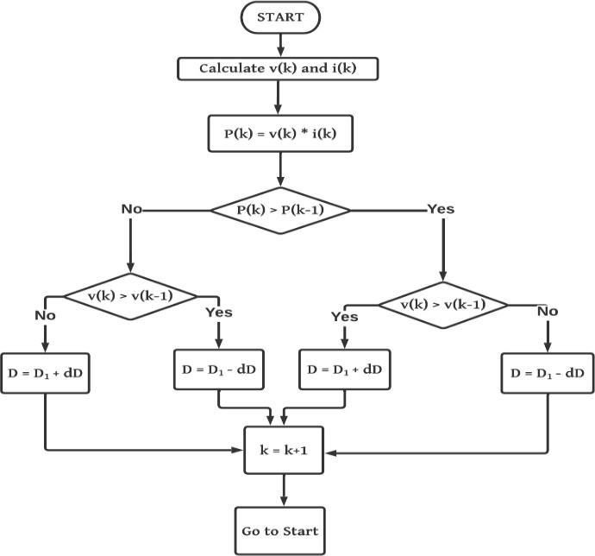

#### Fig 3.1: Flow Chart for P&O Based MPPT

* 1. **Particle Swarm Optimisation**

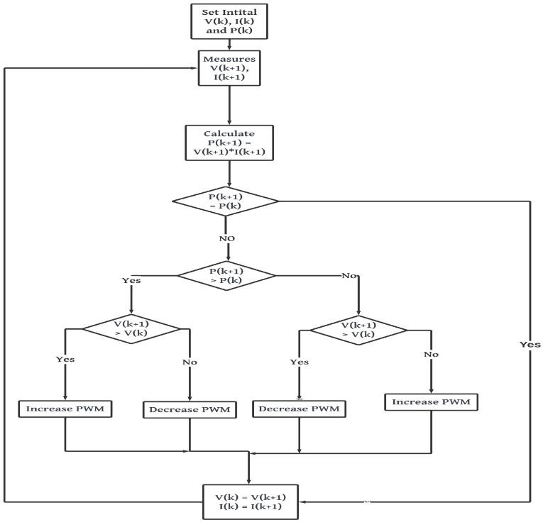

#### Fig 3.2: Flow Chart for PSO Based MPPT

This process searches the optimal solution using a population of particles. Each particle has certain of knowledge. Then, it will move about the search space based on this knowledge. The position and the velocity of the particles are changing and adjusted according to the communication between the particles and each individual’s own experience simultaneously. The individual particles

update their particle positions and velocities by searching for their past the best position assumed so far in order to lead finally to an optimal solution where the particles converge. Each individual particle i is characterized by the current position x, the current velocity v, and the best position in the search space.

The advantages of PSO compared to other evolutionary computational techniques are:

* + - PSO is easy to implement
    - There are few parameters to be adjusted in PSO.
    - All the particles tend to converge to the best solution rapidly. Each particle tries to modify its position using the following information:

1. The current position.
2. The current velocity.
3. The distance between the current position and pbest (local best position).
4. The distance between the current position and the gbest(global best position).

**CHAPTER 4**

**LITERATURE REVIEW**

Electric vehicle in automobiles industry is playing a crucial role as it cut off the production of pollution. While the other vehicle running with diesel, petrol and other non -renewable sources produces pollution which affects environment **[4].**

In Electric Vehicle, Battery seeks more attention than any other part. As of now in conventional methods of charging there are many things which affects the environment in many ways like limitation of resources **[3],** losses to the system. Solar energy is one of the better option presents at the time which is more efficient and present in ample quantity in nature **[10].**

To work with solar energy for better results a technique is used to make system more efficient called MPPT i.e., Maximum power point tracker. This tracks from where we can get maximum power and can give to the system to make system efficient, economical, eco-friendly **[9].**

A mathematical model of PV Panel is built to analyse PV panel output Power in different conditions respect to temperature degree, solar radiation level. By using the designed PV model, we be able to analyse the solar system and know how it will behave before implementing it. Moreover, we present one of the most famous MPPT algorithms (Perturb & Observation, "P&O") with PV panel, in order to keep a constant value of PV output power **[11].**

A study assesses the impact of electric vehicle (EV) uptake and large-scale photovoltaic (PV) investment on the economics of future electricity-generation portfolios. A Monte-Carlo-based portfolio modelling tool was used to assess the expected overall industry cost, associated cost uncertainty, and CO2 emissions of future generation portfolios, where both EVs and PV generation have achieved major deployment. Results show that there are potentially valuable

17

synergies between PV generation and EV charging demand in minimizing future electricity industry costs, cost uncertainties, and emissions, particularly when EV charging loads can be managed**[21].**

Thevenin's elements depend on ambient temperature conditions, so charging is derived and simplified to construct a model that closely predicts and demonstrates adequate PV cell characteristic for different ambient temperature conditions. This method is very useful for estimating the desired performance and also for examining different Maximum Power Point Tracking (MPPT) algorithms **[22].**

18

**CHAPTER 5**

**CONVENTIONAL CHARGING METHODOLOGY**

**5.1 Conventional Charging Methodology**

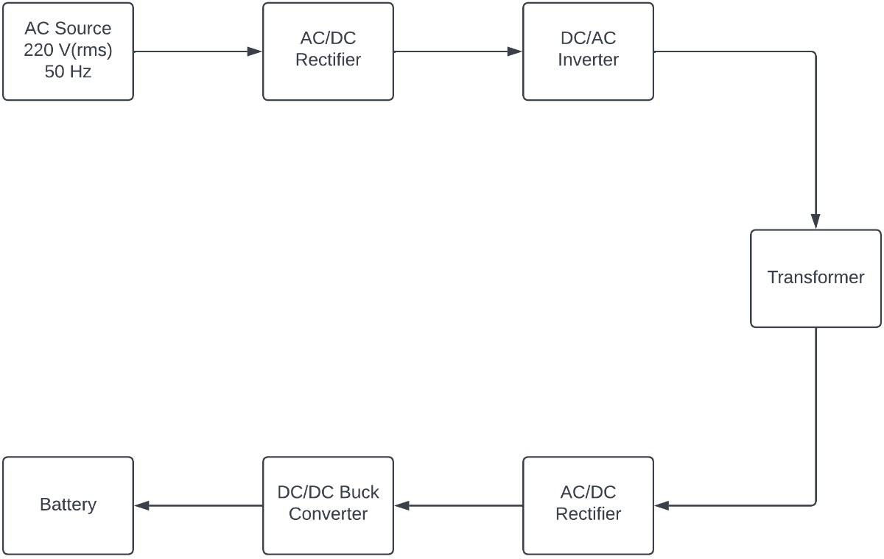

#### Fig 5.1: Block Diagram of Conventional Model

This conventional method of charging contains an AC source through which AC input is given to a rectifier which converts AC to DC and thereafter an inverter is connected to convert that DC to AC so that it can be transmitted to a distance. At the receiving side, there is again an AC/DC rectifier which converts AC to DC and after that, that fixed DC is converted to variable DC using a DC/DC buck converter and this variable DC makes the battery charge.

#### AC/DC Rectifier

Rectification is the process of conversion of alternating input voltage to direct output voltage. As stated before, a rectifier converts AC power to DC power. In diode-based rectifiers, the output voltage cannot be controlled.

19

In this section, uncontrolled single-phase rectifiers are studied. The diode is assumed ideal as before.

A rectifier may be half-wave type or full-wave type. A half-wave rectifier is one in which current in any one line, connected to AC source, is unidirectional. However, a full-wave rectifier has bidirectional current in any one line connected to ac surface.

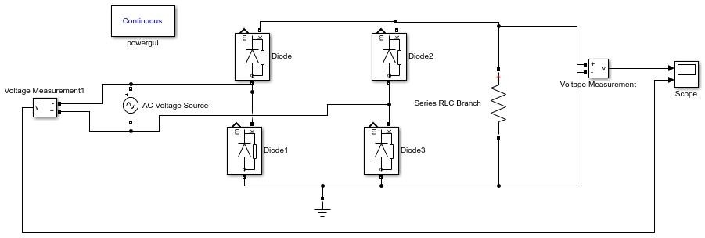

#### Fig 5.2: Circuit for full wave rectifier

* 1. **DC/AC Inverter**

A circuit that converts DC power into AC power at desired voltage and frequency is called an inverter. Some industrial applications of inverters are for adjustable- speed ac drives, induction heating, stand by air-craft power supplies, UPS (uninterruptible power supplies) for computers, HVDC transmission lines etc. But line-commutated inverters require at the output terminals an existing ac supply which is used for their line commutation. This means that line- commutated inverters cannot function as isolated ac voltage sources or as variable frequency generators with dc power at the input. Therefore, voltage level, frequency and waveform on the ac side of line commutated inverters

cannot be changed. On the other hand, the types of inverters, discussed in this chapter, provide an independent ac output voltage of adjustable voltage and adjustable frequency and have, therefore, much wider range of applications.

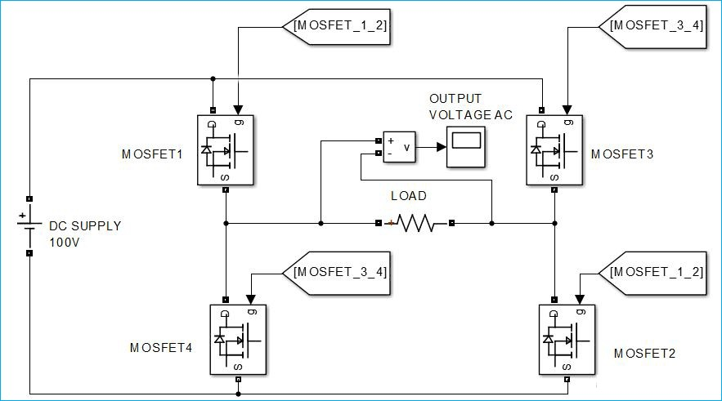

#### Fig 5.3: Circuit for full bridge inverter

* 1. **DC/DC Buck-Boost Converter**

A DC-DC converter/chopper is a static circuit that converts fixed DC input voltage to a variable DC output voltage directly. A chopper may be thought of as DC equivalent of an AC transformer since they behave in an identical manner. As choppers involve one stage conversion, these are more efficient. Choppers are of three types Step-Down chopper (Buck converter), Step-Up chopper (Boost converter) and Step-Up/Step-Down chopper (Buck-Boost converter).

Choppers are now being used all over the world for rapid transit systems. These are also used in trolley cars, marine hoists, forklift trucks and mine haulers. The future electric automobiles are likely to use choppers for their speed control and braking. Chopper systems offer smooth control, high efficiency, fast response and regeneration.

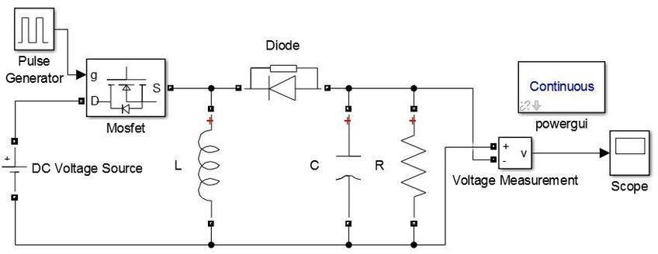

#### Fig 5.4: Circuit for buck-boost converter

## CHAPTER 6

**PROPOSED CHARGING METHODOLOGY**

#### Proposed Charging Methodology

Conventional type of charging has limited source and due to a greater number of switches from input to output, switching losses present in this are more, due to which output power in battery is lowered as compare to that in renewable charging method with same input rating. To overcome this, an alternate methodology is used that is based on solar energy transfer using MPPT controller. In this project we are doing the MATLAB simulation of a battery charging from solar energy by using DC/DC buck converter with MPPT control. Buck converter is used with a battery connected at output terminal. The battery charging current is decided by the MPPT. Below is the block diagram of proposed methodology for Charging of EV with Solar energy using MPPT Controller.

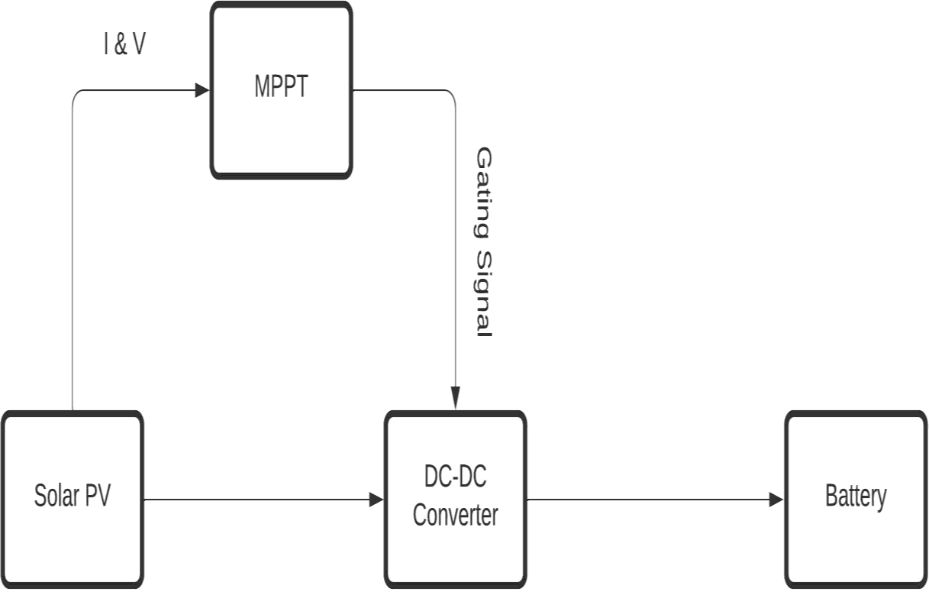

#### Fig.6.1: Block Diagram of Proposed Model

The MPPT or Maximum Power Point Tracking is an algorithm that is used in charge controllers for extracting maximum available power from PV module under certain conditions. The voltage at which PV module can produce maximum power is called maximum power point (or peak power voltage). Maximum power varies with solar radiation, ambient temperature and solar cell temperature. Therefore, to find the maximum power from solar PV, we have used this algorithm.

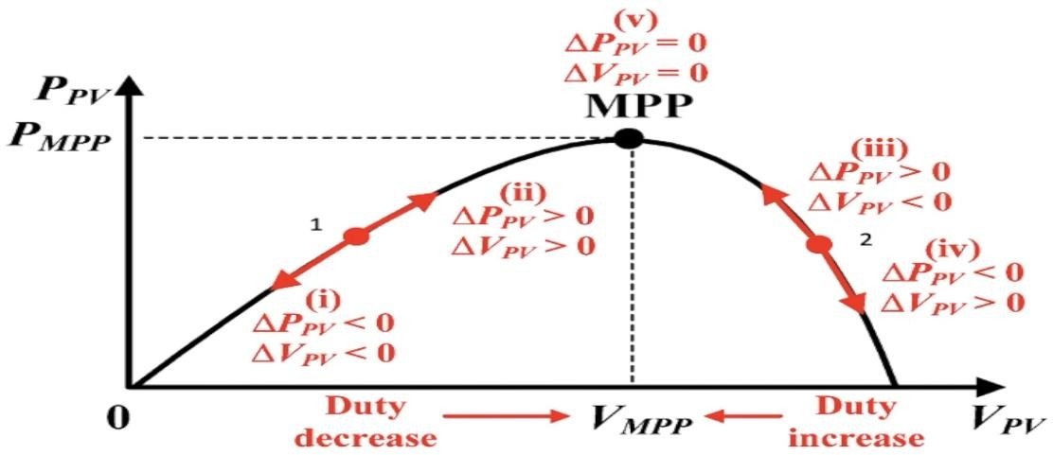

#### Fig.6.2: PV-Curve

MPPT stands for maximum power point tracking, In the case of the photovoltaic modules there is one single operating point at any given point in time where maximum power can be drawn so we need to locate this point or track this point and see the operating point of MPPT module is always at that point are hovering near and around that point. The process of doing this is always trying to maintain the operating point of the PV panels at maximum power point is called maximum power point tracking.

Below is the block diagram which depicts each step that was used in MPPT controller to extract maximum available power from PV module.

#### Flowchart for MPPT Algorithm

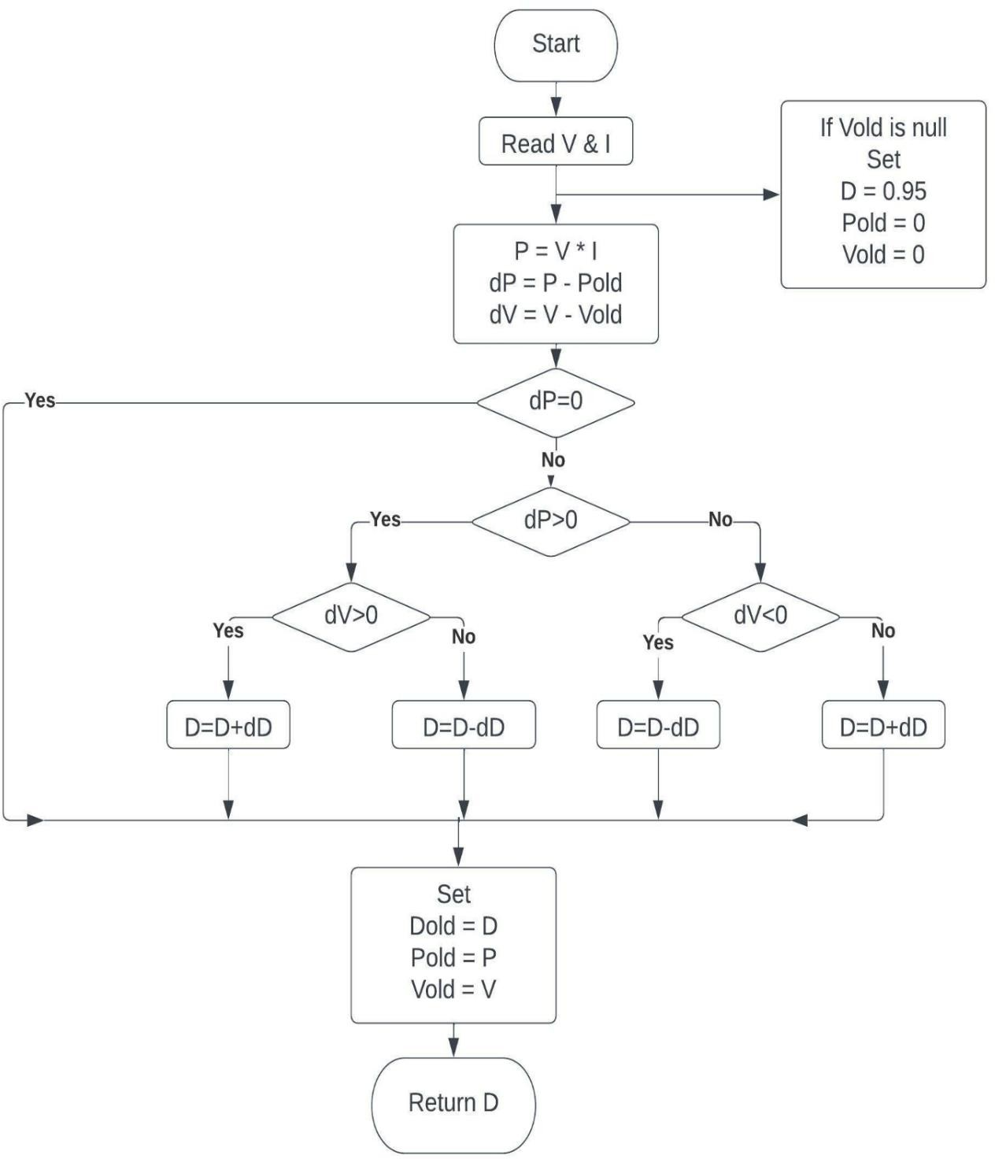

**Fig.6.3: Algorithm Used for MPPT**

First of all, we will read voltage and current from solar PV with the help of MATLAB function block. After that we initialize three variable duty cycle, previous power and previous voltage and check if previous voltage is null then we assign duty cycle to 0.95 and previous power and previous voltage to zero. After assigning the variable we find the current power by multiplying current

voltage and power and difference in power and voltage from previous one and store it into P, dP and dV respectively. After that we check that if change is power is zero then we have to do nothing. Simply we have to assign Duty Cycle, previous power and previous voltage to current one and return the duty cycle but if change is power is not zero then we use a logic to achieve the required duty cycle to get the maximum power from solar PV.

As we can see in the figure 4.2 that this is the graph between power and voltage. Power is increasing from zero to maximum and after that power is decreasing from maximum to zero. Now let’s first go to the point 1 so as you can see so say for instance it moves from point 1 to downwards arrow then it basically goes down then power would be decreasing and voltage would also be decreasing so if this is the case we actually want to move towards the maximum power point so for that to happen we must increase the power and this can be done by increasing the voltage and now if we move upward arrow side then power is increasing and voltage is increasing but we have to move toward maximum power point then we have to increase the power and we can achieve this by increasing the voltage. In both cases duty cycle must be decreases. and for point 2 due to similarly theory voltage must be decreasing to achieve the maximum power point and duty cycle must be increasing to achieve the maximum power point. This same logic we use in MPPT to achieve the maximum power point.

## CHAPTER 7 SIMULATION AND RESULTS

#### Charging of EV with Solar energy using MPPT Controller

Above explained system of charging method is implemented in MATLAB/Simulink with the following parameters:

|  |  |
| --- | --- |
| **PARAMETER** | **VALUE** |
| Irradiation | 1000 W/m2 |
| Temperature | 25 **°** C |
| Nominal Voltage | 12 V |
| Resistance | 1 milli ohms |
| Filter Inductor | 0.783 mH |
| Filter Capacitor | 364 uF |
| Initial SOC | 45 % |

#### Table.7.1: Parameters for Simulink model

Here, irradiance and temperature are taken as standard values which is most commonly used and found i.e., temperature as 25 **°** C which is room temperature and irradiance as 1000 W/m2. And initial SOC is taken as 45% so that charging could be observed. Following is the Simulink model and Simulink result of Charging of EV with Solar energy using MPPT Controller.

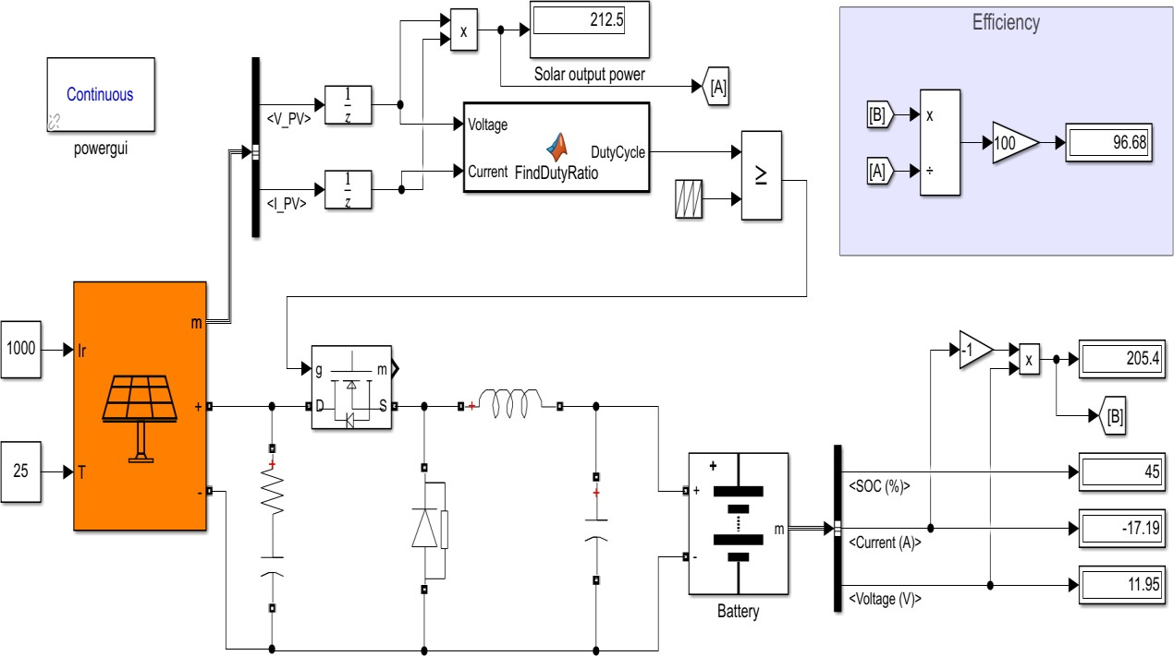

#### Fig.7.1: Simulink Model for Charging of EV with Solar energy

As you can see that the in the above Simulink model the irradiation is 1000 and temperature is 25 degrees and the total efficiency coming out of this charging method is nearly 96 percent. Below is the graph of charging battery starting from 45% at t=0 second.

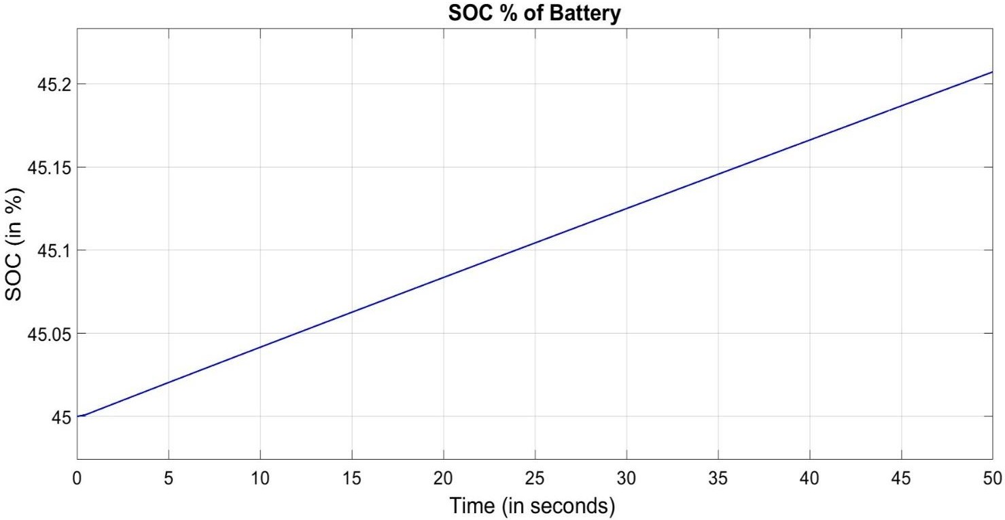

#### Fig.7.2: Simulation result

Below figure is the current – voltage and power – voltage curve of the array. The red line in the below graph is the MPPT power, voltage and current at 1000 irradiation and all the lines below red one have less irradiation than 1000. Therefore, from this we can conclude that the more the irradiation more the power in array and vice versa.

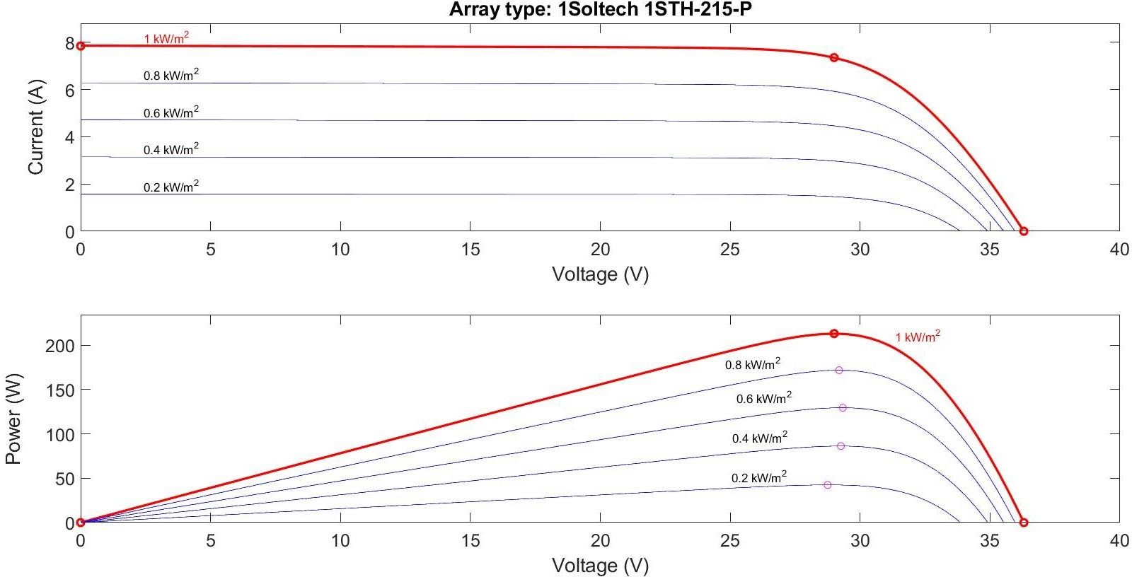

#### Fig.7.3: IV and PV Curve for the Array

* 1. **Comparison Between Both the Charging Methodology**

|  |  |  |
| --- | --- | --- |
| **SPECIFICATIONS** | **CONVENTIONAL** | **PROPOSED** |
| Efficiency | Less efficient than proposed method (83-88%) | More efficient (90-95%) |
| Switching Losses | More switching losses | Less switching losses |
| Complexity | More components therefore more complex | Less components therefore less complex |
| Cost | More expensive due to more components | Less expensive due to more components |
| Dependency | Non-renewable source | Renewable source |

#### Table.7.2: Comparison b/w conventional and proposed methodology

**CONCLUSION & FUTURE SCOPE**

As battery plays a vital role in electric vehicles, its charging becomes attention seeker to many researchers, so as of now there are many conventional methods of charging using non-renewable sources which are limited in environment. Solar energy can be better substitute to conventional method as it is the renewable source of energy, present in ample amount in environment but it is flow-limited. Therefore, Solar energy plays a vital role in upcoming Electric Vehicles for charging the battery.

Further, MPPT is used to track the maximum power point which results in more efficient system as in proposed method, efficiency comes to be approximately 90-95% in average but in the conventional method efficiency of the system is less than the proposed method that is 83-88%. Also proposed method is less complex due to which switching losses are less compared to conventional that are complex. In last, this proposed system is more economical than the conventional one.

In future, various modifications can be done in converters to achieve maximum gain in the output. Wireless charging can also be implemented with an increased distance between primary coil and secondary coil to reduce losses hence, maximising efficiency. This can bring revolution in the automobile industry by making charging system of Electric Vehicle smarter and more reliable.

## REFERENCES

[1]. Rong Zeng, Veda Galigekere, Omer Onar and Burak Ozpineci, “Optimized renewable energy integration for EV high-power dynamic wireless charging systems" | 978-1-7281-8897-3/21/$31.00 ©2021 IEEE | DOI: 10.1109/ISGT49243.2021.9372265

[2]. Anjeet Verma, Bhim Singh, A. Chandra and Kamal Al-Haddad, "An Implementation of Solar PV Array Based Multifunctional EV Charger” | 0093- 9994 ©2020 IEEE | DOI: 10.1109/TIA.2020.2984742

[3]. Anjeet Verma, Bhim Singh, A. Chandra and Kamal Al-Haddad, "Implementation of Solar PV- Battery and Diesel Generator Based Electric Vehicle Charging Station" | 0093-9994 ©2020 IEEE | DOI: 10.1109/TIA.2020.2989680

[4]. Thiruvonasundari Duraisamy, Deepa kaliyaperumal, "Active cell balancing for electric vehicle battery management system" International Journal of Power Electronics and Drive System (IJPEDS) Vol. 11, No. 2, June 2020, pp. 571~579

| DOI: 10.11591/ijpeds. v11.i2.pp571-579

[5]. Anjeet Verma and Bhim Singh, "CAPSA Based Control for Power Quality Correction in PV Array Integrated EVCS Operating in Standalone and Grid Connected Modes”, IEEE TRANSACTIONS ON INDUSTRY APPLICATIONS, VOL. 57, NO. 2, MARCH/APRIL 2021 | 0093-9994 ©2020 IEEE | DOI: 10.1109/ISOCC50952.2020.9332950

[6]. Philip Machura, Valerio De Santis and Quan Li, "Driving Range of Electric Vehicles Charged by Wireless Power Transfer”, |0018-9545 ©2020 IEEE | DOI: 10.1109/TVT.2020.2984386

[7]. Qijun Deng, Yuanfeng Cheng, Fengwei Chen and Dariusz Czarkowski, " Wired/Wireless Hybrid Charging System for Electrical Vehicles with Minimum

Rated Power Requirement for DC Module", | 0018-9545 (c) 2020 IEEE | DOI: 10.1109/TVT.2020.3019787

[8]. Kishore Naik Mude, " Battery Charging Method for Electric Vehicles: From Wired to On-Road Wireless Charging", Chinese Journal of Electrical Engineering, Vol.4, No.4, December 2018, DOI: 10.23919/CJEE.2018.8606784

[9] GAGA Ahmed, ERRAHIMI Fatima, ES-SBAI Najia, “Design and implementation of MPPT solar system based on the enhanced P&O algorithm using Labview” Faculty of Science and Technology| 978-1-4799-7336- 1/14/$31.00 ©2014 IEEE

[10]. Anjeet Verma and Bhim Singh, "AFF-SOGI-DRC Control of Renewable Energy Based Grid Interactive Charging Station for EV with Power Quality Improvement" | 0093-9994 ©2020 IEEE | DOI: [10.1109/TIA.2020.3029547](https://doi.org/10.1109/TIA.2020.3029547)

1. P. T. szemes and M. Melhem, "Analyzing and modeling PV with “P&O” MPPT Algorithm by MATLAB/SIMULINK," 2020 3rd International Symposium on Small-scale Intelligent Manufacturing Systems (SIMS), 2020, pp. 1-6, doi: 10.1109/SIMS49386.2020.9121579.
2. V. K. Yadav, S. K. Jha and B. Kumar, "Comparative Study of Different Variable Step Size Perturb and Observe based MPPT," 2020 International Conference on Advances in Computing, Communication & Materials (ICACCM), 2020, pp. 272-277, doi: 10.1109/ICACCM50413.2020.9212944.
3. S. Thakran, J. Singh, R. Garg and P. Mahajan, "Implementation of P&O Algorithm for MPPT in SPV System," 2018 International Conference on Power Energy, Environment and Intelligent Control (PEEIC), 2018, pp. 242-245, doi: 10.1109/PEEIC.2018.8665588.
4. D. Jiandong, X. Ma and S. Tuo, "A Variable Step Size P&O MPPT Algorithm for Three-Phase Grid-Connected PV Systems," 2018 China International Conference on Electricity Distribution (CICED), 2018, pp. 1997- 2001, doi : 10.1109/CICED.2018.8592040.
5. T. Selmi, M. Abdul-Niby, L. Devis and A. Davis, "P&O MPPT implementation using MATLAB/Simulink," 2014 Ninth International Conference on Ecological Vehicles and Renewable Energies (EVER), 2014, pp. 1-4, doi: 10.1109/EVER.2014.6844065.
6. M. Oliinyk, J. Džmura and D. Pál, "The impact of a electric vehicle charging on the distribution system," 2020 21st International Scientific Conference on Electric Power Engineering (EPE), 2020, pp. 1-5, doi: 10.1109/EPE51172.2020.9269213.
7. R. Liu, X. Zong and X. Mu, "Electric vehicle charging control system based on the characteristics of charging power," 2017 Chinese Automation Congress (CAC), 2017, pp. 3860-3840, doi: 10.1109/CAC.2017.8243449.
8. J. linru, Z. yuanxing, L. taoyong, D. xiaohong and Z. jing, "Analysis on Charging Safety and Optimization of Electric Vehicles," 2020 IEEE 6th International Conference on Computer and Communications (ICCC), 2020, pp. 2382-2385, doi: 10.1109/ICCC51575.2020.9344906.
9. A. G. Akhil et al., "Coupled Wireless Charging system for Electric Vehicles," 2021 Third International Conference on Intelligent Communication Technologies and Virtual Mobile Networks (ICICV), 2021, pp. 475-479, doi: 10.1109/ICICV50876.2021.9388458.
10. D. Niculae, M. Iordache, M. Stanculescu, M. L. Bobaru and S. Deleanu, "A Review of Electric Vehicles Charging Technologies Stationary and Dynamic," 2019 11th International Symposium on Advanced Topics in Electrical Engineering (ATEE), 2019, pp. 1-4, doi: 10.1109/ATEE.2019.872494
11. P. Vithayasrichareon, G. Mills and I. F. MacGill, "Impact of Electric Vehicles and Solar PV on Future Generation Portfolio Investment," in *IEEE Transactions on Sustainable Energy*, vol. 6, no. 3, pp. 899-908, July 2015, doi: 10.1109/TSTE.2015.2418338.
12. Rajiv K. Varma, "EMERGING TRENDS WITH SMART SOLAR PV INVERTERS," in Smart Solar PV Inverters with Advanced Grid Support Functionalities , IEEE, 2022, pp.431-464, doi: 10.1002/9781119214236.ch9.